**Question 1:** Simplify fulladder

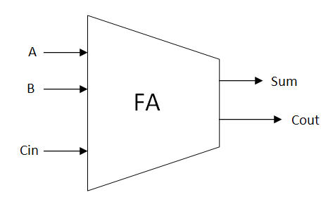

**Figure:** SimplifiedFull-Adder circuit

In previous lab, you have asked to design Full-Adder module by designing low-level of XOR and AND gates and construct all as a top-level to created Full-Adder. The simplified Full-Adder consists of three inputs (A, B & Cin) and two outputs (Sum & Cout). By using Boolean expression below,

Sum = (A XOR B) XOR Cin;

Cout = (A AND B) OR (A AND Cin) OR ( B AND Cin)

Write a VHDL code of simplified Full-Adder based on Boolean expression given. Then, create it testbench running at 80ns and your waveform result should equivalent with truth table given.

|  |  |  |  |  |
| --- | --- | --- | --- | --- |
| **A** | **B** | **Cin** | **Sum** | **Cout** |
| 0 | 0 | 0 | 0 | 0 |
| 0 | 0 | 1 | 1 | 0 |
| 0 | 1 | 0 | 1 | 0 |
| 0 | 1 | 1 | 0 | 1 |
| 1 | 0 | 0 | 1 | 0 |
| 1 | 0 | 1 | 0 | 1 |
| 1 | 1 | 0 | 0 | 1 |
| 1 | 1 | 1 | 1 | 1 |

**Figure:** Full-Adder truth table

**Result:**

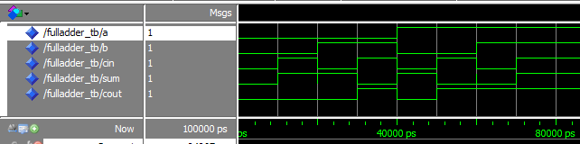

**Answer:**

**Behavioral code:**

library ieee;

use ieee.std_logic_1164.all;

entity simplify_fulladder is

port ( A : in std_logic;

B : in std_logic;

Cin : in std_logic;

Sum : out std_logic;

Cout : out std_logic);

end simplify_fulladder;

architecture behav of simplify_fulladder is

begin

Sum <= (A xor B) xor Cin;

Cout <= (A and B) or (A and Cin) or (B and Cin);

end behav;

**Testbench:**

library ieee;

use ieee.std_logic_1164.all;

use ieee.std_logic_arith.all;

use ieee.std_logic_unsigned.all;

entity simfulladder_tb is -- entity declaration

end simfulladder_tb;

architecture TB of simfulladder_tb is

component simplify_fulladder

PORT ( A : in std_logic;

B : in std_logic;

Cin : in std_logic;

Sum : out std_logic;

Cout : out std_logic);

end component;

signal a : std_logic;

signal b : std_logic;

signal cin : std_logic;

signal sum : std_logic;

signal cout : std_logic;

begin

DUT: simplify_fulladder port map (

A=>a,

B=>b,

Cin=>cin,

Sum=>sum,

Cout=>cout);

process

begin

a<= '0'; b<= '0'; cin<='0'; wait for 10 ns;

a<= '0'; b<= '0'; cin<='1'; wait for 10 ns;

a<= '0'; b<= '1'; cin<='0'; wait for 10 ns;

a<= '0'; b<= '1'; cin<='1'; wait for 10 ns;

a<= '1'; b<= '0'; cin<='0'; wait for 10 ns;

a<= '1'; b<= '0'; cin<='1'; wait for 10 ns;

a<= '1'; b<= '1'; cin<='0'; wait for 10 ns;

a<= '1'; b<= '1'; cin<='1'; wait for 10 ns;

wait;

end process;

end TB;

**Question 2:** Generate Block for 4-bit Full-Adder.

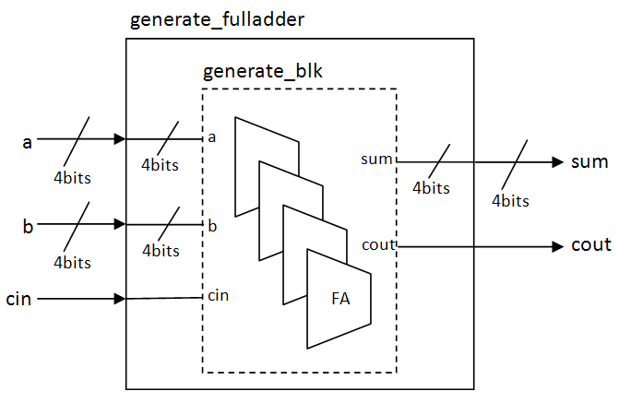

**Figure:** The generate4-bit Full-Adder module

Figure above illustrated generate 4-bit Full-Adder Module. It has low-level design of Full-Adder which is generated 4 times inside block generate_blk. This block functional is same as 4-bit Full-Adder. Top-level (generate_fulladder) has three inputs (a, b, cin) which two of the inputs convey 4-bits signal (e.g. “0011”) and two outputs (sum, cout) which sum convey 4-bits output signal.

Base on connection above, write VHDL code for generate 4-bit Full-Adder design. Then, create it testbench running at 80ns and your waveform result should equivalent with truth table given.

Below is the snippet how to generate the 4-bits Full-Adder:

generate_blk : for i in 3 downto 0 generate

begin

FA : simplify_fulladder port map (a(i),b(i),c(i),sum(i),c(i+1));

end generate generate_blk;

|  |  |  |  |  |  |  |  |  |  |  |  |  |  |
| --- | --- | --- | --- | --- | --- | --- | --- | --- | --- | --- | --- | --- | --- |
| **a3** | **a2** | **a1** | **a0** | **b3** | **b2** | **b1** | **b0** | **Cin** | **sum3** | **sum2** | **sum1** | **sum0** | **cout** |
| 0 | 0 | 0 | 1 | 0 | 0 | 1 | 0 | 1 | 0 | 1 | 0 | 0 | 0 |
| 0 | 1 | 0 | 1 | 0 | 0 | 1 | 1 | 1 | 1 | 0 | 0 | 1 | 0 |
| 0 | 1 | 1 | 1 | 0 | 0 | 0 | 1 | 1 | 1 | 0 | 0 | 1 | 0 |
| 1 | 1 | 1 | 1 | 1 | 1 | 1 | 1 | 1 | 1 | 1 | 1 | 1 | 1 |
| 1 | 0 | 0 | 1 | 0 | 1 | 0 | 1 | 0 | 1 | 1 | 1 | 0 | 0 |
| 1 | 1 | 0 | 0 | 0 | 1 | 0 | 1 | 0 | 0 | 0 | 0 | 1 | 1 |
| 1 | 0 | 1 | 0 | 0 | 1 | 0 | 1 | 0 | 1 | 1 | 1 | 1 | 0 |
| 1 | 1 | 1 | 1 | 1 | 1 | 1 | 1 | 0 | 1 | 1 | 1 | 0 | 1 |

**Figure:** Generate 4-bits Full-Adder truth table

**Result:**

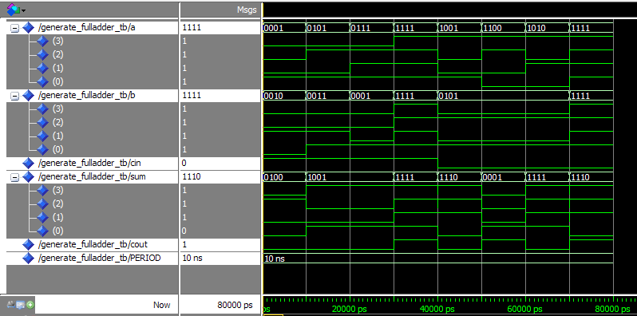

**Answer:**

**Behavioral code:**

--simplify_fulladder------------------------------------------------------

library ieee;

use ieee.std_logic_1164.all;

entity simplify_fulladder is

port ( A : in std_logic;

B : in std_logic;

Cin : in std_logic;

Sum : out std_logic;

Cout : out std_logic);

end simplify_fulladder;

architecture behav of simplify_fulladder is

begin

Sum <= (A xor B) xor Cin;

Cout <= (A and B) or (A and Cin) or (B and Cin);

end behav;

--AND gate-----------------------------------------------------

library ieee;

use ieee.std_logic_1164.all;

entity generate_fulladder is

port ( a : in std_logic_vector(3 downto 0);

b : in std_logic_vector(3 downto 0);

cin : in std_logic;

sum : out std_logic_vector(3 downto 0);

cout : out std_logic);

end generate_fulladder;

architecture behav of generate_fulladder is

component simplify_fulladder

port( A : in std_logic;

B : in std_logic;

Cin : in std_logic;

Sum : out std_logic;

Cout : out std_logic);

end component;

signal c:std_logic_vector(4 downto 0);

begin

c(0) <= cin;

generate_blk : for i in 3 downto 0 generate

begin

FA0 : simplify_fulladder port map (a(i),b(i),c(i),sum(i),c(i+1));

end generate generate_blk;

cout <= c(4);

end behav;

**Testbench:**

library ieee;

use ieee.std_logic_1164.all;

use std.textio.all;

use work.all;

entity generate_fulladder_tb is

end generate_fulladder_tb;

architecture tb of generate_fulladder_tb is

component generate_fulladder is

port ( a : in std_logic_vector(3 downto 0);

b : in std_logic_vector(3 downto 0);

cin : in std_logic;

sum : out std_logic_vector(3 downto 0);

cout : out std_logic);

end component;

constant PERIOD: time := 10 ns;

signal a: std_logic_vector(3 downto 0);

signal b: std_logic_vector(3 downto 0);

signal cin: std_logic;

signal sum : std_logic_vector(3 downto 0);

signal cout: std_logic;

begin

DUT: generate_fulladder port map ( a, b, cin, sum, cout);

INPUTS: process

begin

a<= "0001"; b<= "0010"; cin<='1';

wait for PERIOD;

a<= "0101"; b<= "0011"; cin<='1';

wait for PERIOD;

a<= "0111"; b<= "0001"; cin<='1';

wait for PERIOD;

a<= "1111"; b<= "1111"; cin<='1';

wait for PERIOD;

a<= "1001"; b<= "0101"; cin<='0';

wait for PERIOD;

a<= "1100"; b<= "0101"; cin<='0';

wait for PERIOD;

a<= "1010"; b<= "0101"; cin<='0';

wait for PERIOD;

a<= "1111"; b<= "1111"; cin<='0';

wait for PERIOD;

wait;

end process INPUTS;

end tb;

**Question 3:** Structure and Assert statement in Generate 4-bit Full-Adder.

Refer to the Question1, design a structure 4-bits Full-Adder by using simplify_fulladder. Then, create a testbench for both struct_fulladder module and generate_fulladder module and in the end of the testbench codes, implement Assert statement to ensure the output of both are no different.

Below is the snippet how to insert Assert statement:

verify : process is

begin

wait for PERIOD;

assert sim_sum = gen_sum and sim_cout = gen_cout

report "implementations have different outputs"

severity error;

-- wait on a,b,cin;

end process verify;

**Answer:**

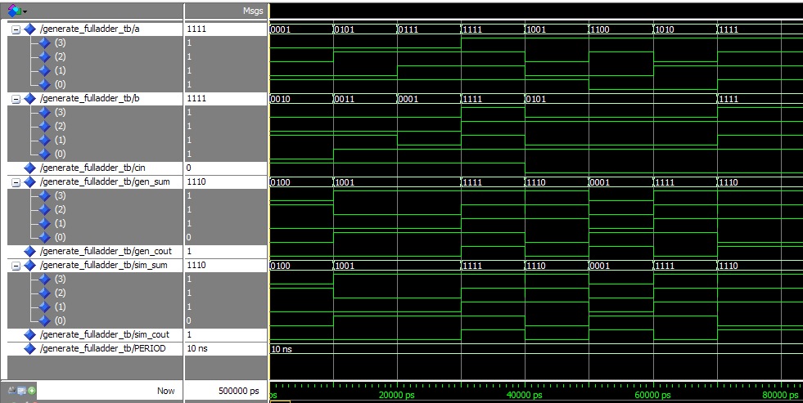

**Testbench:**

library ieee;

use ieee.std_logic_1164.all;

use std.textio.all;

use work.all;

entity generate_fulladder_tb is

end generate_fulladder_tb;

architecture tb of generate_fulladder_tb is

component struct_fulladder is

port ( a : in std_logic_vector(3 downto 0);

b : in std_logic_vector(3 downto 0);

cin : in std_logic;

sum : out std_logic_vector(3 downto 0);

cout: out std_logic);

end component;

component generate_fulladder is

port ( a : in std_logic_vector(3 downto 0);

b : in std_logic_vector(3 downto 0);

cin : in std_logic;

sum : out std_logic_vector(3 downto 0);

cout : out std_logic);

end component;

constant PERIOD: time := 10 ns;

signal a: std_logic_vector(3 downto 0);

signal b: std_logic_vector(3 downto 0);

signal cin: std_logic;

signal gen_sum : std_logic_vector(3 downto 0);

signal gen_cout: std_logic;

signal sim_sum : std_logic_vector(3 downto 0);

signal sim_cout: std_logic;

begin

DUT0: struct_fulladder port map ( a, b, cin, sim_sum, sim_cout);

DUT1: generate_fulladder port map ( a, b, cin, gen_sum, gen_cout);

INPUTS: process

begin

a<= "0001";

b<= "0010";

cin<='1';

wait for PERIOD;

a<= "0101";

b<= "0011";

cin<='1';

wait for PERIOD;

a<= "0111";

b<= "0001";

cin<='1';

wait for PERIOD;

a<= "1111";

b<= "1111";

cin<='1';

wait for PERIOD;

a<= "1001";

b<= "0101";

cin<='0';

wait for PERIOD;

a<= "1100";

b<= "0101";

cin<='0';

wait for PERIOD;

a<= "1010";

b<= "0101";

cin<='0';

wait for PERIOD;

a<= "1111";

b<= "1111";

cin<='0';

wait for PERIOD;

wait;

end process INPUTS;

verify : process is

begin

wait for PERIOD;

assert sim_sum = gen_sum and sim_cout = gen_cout

report "implementations have different outputs"

severity error;

-- wait on a,b,cin;

end process verify;

end tb;